**Practical No 12**

**Aim :** Develop, debug and Execute a C program to simulate LFU page replacement algorithms

**Apparatus:** Mingw compiler for C/C++, and a text editor for developing C code file (Dev C++).

**Theory :**

**What is Page Replacement Algorithm?**

* In operating systems that use paging for memory management, page replacement algorithms are needed to decide which page needed to be replaced when new page comes in.
* Whenever a new page is referred and not present in memory, page fault occurs and Operating System replaces one of the existing pages with newly needed page.
* Different page replacement algorithms suggest different ways to decide which page to replace.
* The target for all algorithms is to reduce number of page faults.

**What is LFU Page Replacement?**

* LFU is short for Least Frequently Used page replacement Algorithm.
* In LFU algorithm the least frequently used page is removed and replaced with the new page
* LFU is one such page replacement policy in which the least frequently used pages are replaced.
* If the frequency of pages is the same, then the page that has arrived first is replaced first.

**What are the rules for LFU Page Replacement?**

1. **The Page with the smallest/least frequency will be replaced.**
2. **Whenever a page comes/arrives the frequency is increased.**
3. **Whenever a page leaves the memory its frequency is reset.**
4. **If the frequency is same, FIFO is used to decide which page to replace.**

**Example:**

Reference string: 7,0,1,2,0,3,0,4,2,3,0,3,2

No of frames: 3

|  |  |  |  |  |  |  |  |  |  |  |  |  |  |
| --- | --- | --- | --- | --- | --- | --- | --- | --- | --- | --- | --- | --- | --- |
| F3 |  |  | 1 | 1 | 1 | 3 | 3 | 3 | 2 | 2 | 2 | 2 | 2 |
| F2 |  | 0 | 0 | 0 | 0 | 0 | 0 | 0 | 0 | 0 | 0 | 0 | 0 |
| F1 | 7 | 7 | 7 | 2 | 2 | 2 | 2 | 4 | 4 | 3 | 3 | 3 | 3 |
|  | * | * | * | * | HIT | * | HIT | * | * | * | HIT | HIT | HIT |

Page fault (*): 8

Page hit (HIT): 5

Page fault ratio = No. of page fault / No. of reference string

= 8/13

= 61.54%

Page hit ratio = No. of page ratio / No. of reference string

= 5/13

= 38.46%

**Code:**

#include<stdio.h>

int main(){

int no_of_frames, no_of_pages, frames[10], pages[30], temp[10], flag1, flag2, flag3, i, j, k, pos, max, faults = 0;

printf("Enter number of frames: ");

scanf("%d", &no_of_frames);

printf("Enter number of pages: ");

scanf("%d", &no_of_pages);

printf("Enter page reference string: ");

for(i = 0; i < no_of_pages; ++i){

scanf("%d", &pages[i]);

}

for(i = 0; i < no_of_frames; ++i){

frames[i] = -1;

}

for(i = 0; i < no_of_pages; ++i){

flag1 = flag2 = 0;

for(j = 0; j < no_of_frames; ++j){

if(frames[j] == pages[i]){

flag1 = flag2 = 1;

break;

}

}

if(flag1 == 0){

for(j = 0; j < no_of_frames; ++j){

if(frames[j] == -1){

faults++;

frames[j] = pages[i];

flag2 = 1;

break;

}

}

}

if(flag2 == 0){

flag3 =0;

for(j = 0; j < no_of_frames; ++j){

temp[j] = -1;

for(k = i + 1; k < no_of_pages; ++k){

if(frames[j] == pages[k]){

temp[j] = k;

break;

}

}

}

for(j = 0; j < no_of_frames; ++j){

if(temp[j] == -1){

pos = j;

flag3 = 1;

break;

}

}

if(flag3 ==0){

max = temp[0];

pos = 0;

for(j = 1; j < no_of_frames; ++j){

if(temp[j] > max){

max = temp[j];

pos = j;

}

}

}

frames[pos] = pages[i];

faults++;

}

printf("\n");

for(j = 0; j < no_of_frames; ++j){

if(frames[j] == -1)

printf(" \t");

else

printf("%d\t", frames[j]);

}

}

printf("\n\nTotal Page Faults = %d", faults);

printf("\nTotal Page Hits = %d",no_of_pages - faults);

printf("\nPage Fault Ratio = %.2f%%",faults/(float)no_of_pages * 100);

printf("\nPage Hit Ratio = %.2f%%",(no_of_pages - faults)/(float)no_of_pages * 100);

return 0;

}

**Output:**

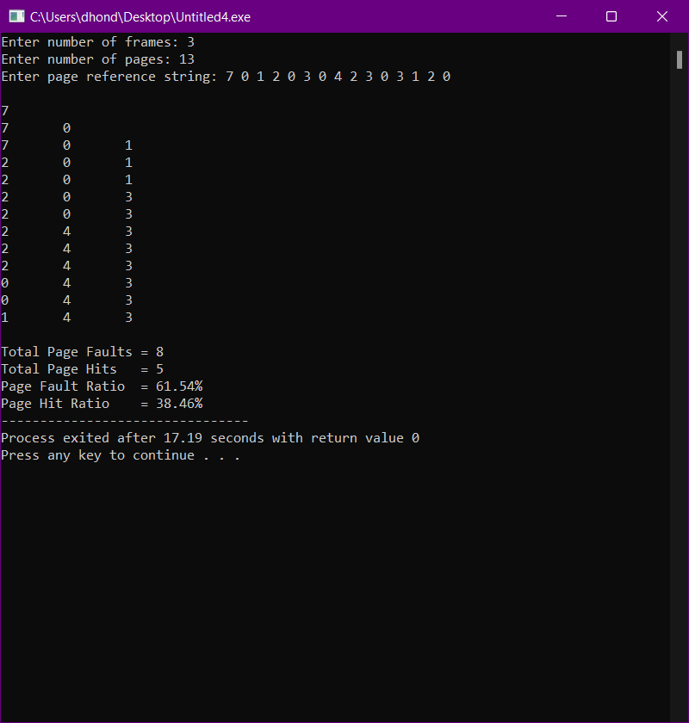

Output 10.1

**Conclusion**:

Hence, by performing this practical I got to know about the LFU page replacement algorithm i.e. Least Frequently Used Page Replacement Algorithm. I also developed, debugged and executed a C program to simulate LFU page replacement algorithm.